December 4, 2025
Martina mallia
WLV NUMBER: 2582991
STC Higher Education, Malta
Patient Medication Record Tracking
Full Stack Development
Contents
Table of Figures 2
GitCommit 3
Introduction 3
Project Overview 3
Core Objectives 5
Entity Relationship Diagram (ERD) Analysis 9
Database Architecture 10
Key Assumptions and Design Rationale 11
Professional Medical Hierarchy 11
Comprehensive Audit Trail 11
Geographic Specificity 11
Session-Based Security 12
Technical Architecture 13
Database Safety Features 13
Enhanced User Experience 13
Security and Compliance 13
Business Value and Clinical Impact 14
Operational Excellence 14
Quality Improvement 14
Risk Management 15
Further improvements 15
Conclusion 15
References 16

Table of Figures
Figure 1 - Create Account 4
Figure 2 - User Account Successful 5
Figure 3 - Patients' Records 5
Figure 4 - Medication Tracking 6
Figure 5 - Before Accepting Or Rejecting Cookies 7
Figure 6 - Changing Cookies' Settings 7
Figure 7 - Weak Password Notification 8
Figure 8 - Entity Relational Diagram 9
Figure 9 - Role Information Display 13

GitCommit
https://github.com/MartinaMallia05/MedicationApp/tree/main

Introduction
Modern healthcare environments demand robust digital systems capable of managing sensitive patient information, ensuring clinical accountability, and supporting regulatory compliance. (Saproo, 2025). Furthermore, it also needs to ensure the reliability of the data and service provided (Meeker & Hong, 2014). The Medical System (MS) described in this document is a comprehensive healthcare software platform designed to streamline patient record management, prescription workflows, and provider historical information of patients’ medication provided by an appropriate practitioner (Bora, 2024).
By integrating professional medical standards with advanced technical architecture, the system serves as a foundational tool for clinics, hospitals, and medical practices seeking efficient and secure digital transformation. (Barbieri, 2023). This report provides a detailed overview of the system’s objectives, entity relationship model, architectural rationale, workflow assumptions, and overall business and clinical impact.

Project Overview
The MS is built around core healthcare data management principles: accurate and secure patient records, precise medication tracking, strict adherence to prescriber authority, and transparent audit trails. (Semantha, 2021). It functions as both an administrative and clinical tool, enabling healthcare professionals to manage patients’ details, document medical history, and issue prescriptions while maintaining full traceability of every action. (Rizzardi, 2024).
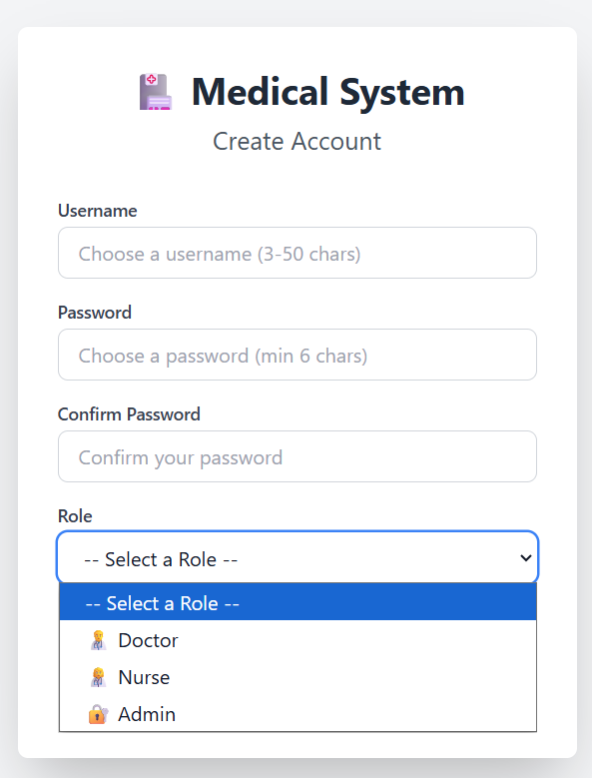
Figure 1 - Create Account
The system is engineered for environments where data protection regulations, such as the GDPR, require rigorous security controls for storing and using patient information. (Shahid, 2022). On registration, the application allows three types of roles: Admin, Nurse or Doctor as in Figure 1 - Create Account. Each role can perform different functions. Therefore, MS promotes data integrity, professional accountability, and safe clinical practice across all user roles. (Prasanna, 2024).

The application will also take care to provide several helpful notifications to users during operations. An example is provided below in Figure 2 - User Account Successful, when a user was registered as a doctor.


Figure 2 - User Account Successful

Core Objectives
The platform has five key objectives central to healthcare IT:
- Patient Data Management
Centralised storage of patient demographics, contact details, medical history, and identifiers ensures a single source of source across the organisation as in Figure 3 - Patients' Records.
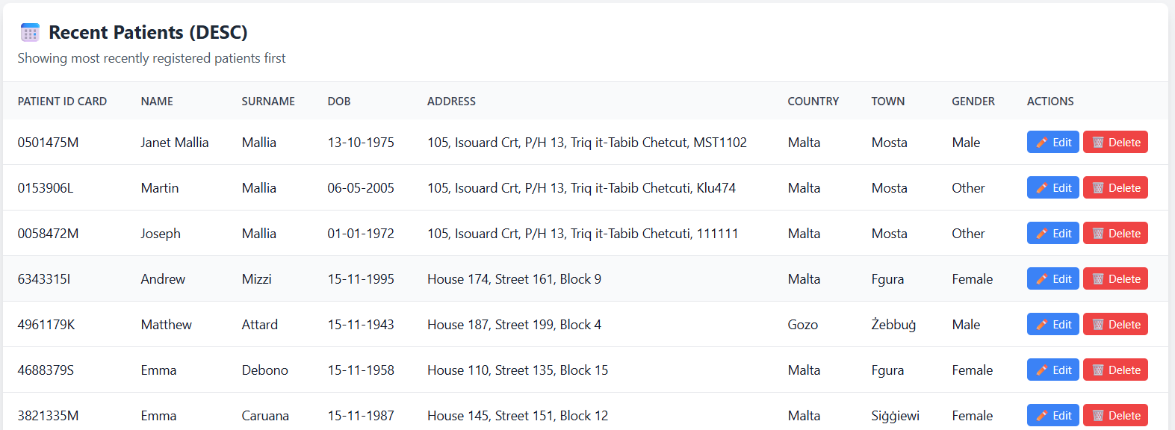
Figure 3 - Patients' Records

- Medication Tracking
A complete audit trail of medication entries, tied directly to the prescribing user saved to the backend (PhpMyAdmin), ensuring clinical safety and legal traceability as in Figure 4 - Medication Tracking.

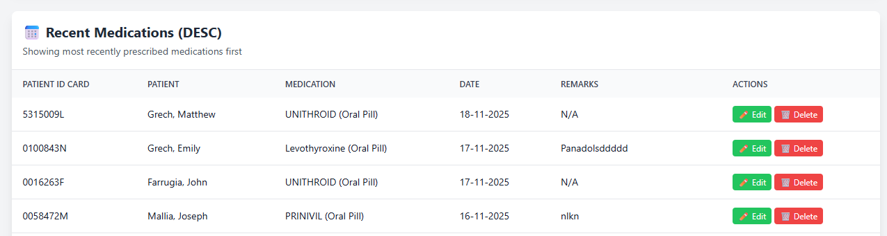
Figure 4 - Medication Tracking

- Role-Based Access Control
Distinct medical roles: doctor, nurse, and administrator determine user permissions, ensuring tasks align with professional competencies and licensing, as in Figure 1 - Create Account.

- Regulatory Compliance
Robust auditing practices, secure user authentication, and data handling techniques ensure compliance with GDPR and healthcare industry standards (Barati, 2021). Cookies are also taken care of, and a clear cache policy is in place to ensure the data of previous users is cleared out. (Kretschmer, 2021).
Cookies can also be configured, and the Cookies banner will remain available in all pages unless an Accept or Reject is selected, as in Figure 5 - Before Accepting Or Rejecting Cookies. Once cookies are selected, these can be changed according to the user’s preference, as in Figure 6 - Changing Cookies' Settings. The application will also take care to highlight weak passwords and provide suggestions to change them, as in Figure 7 - Weak Password Notification.

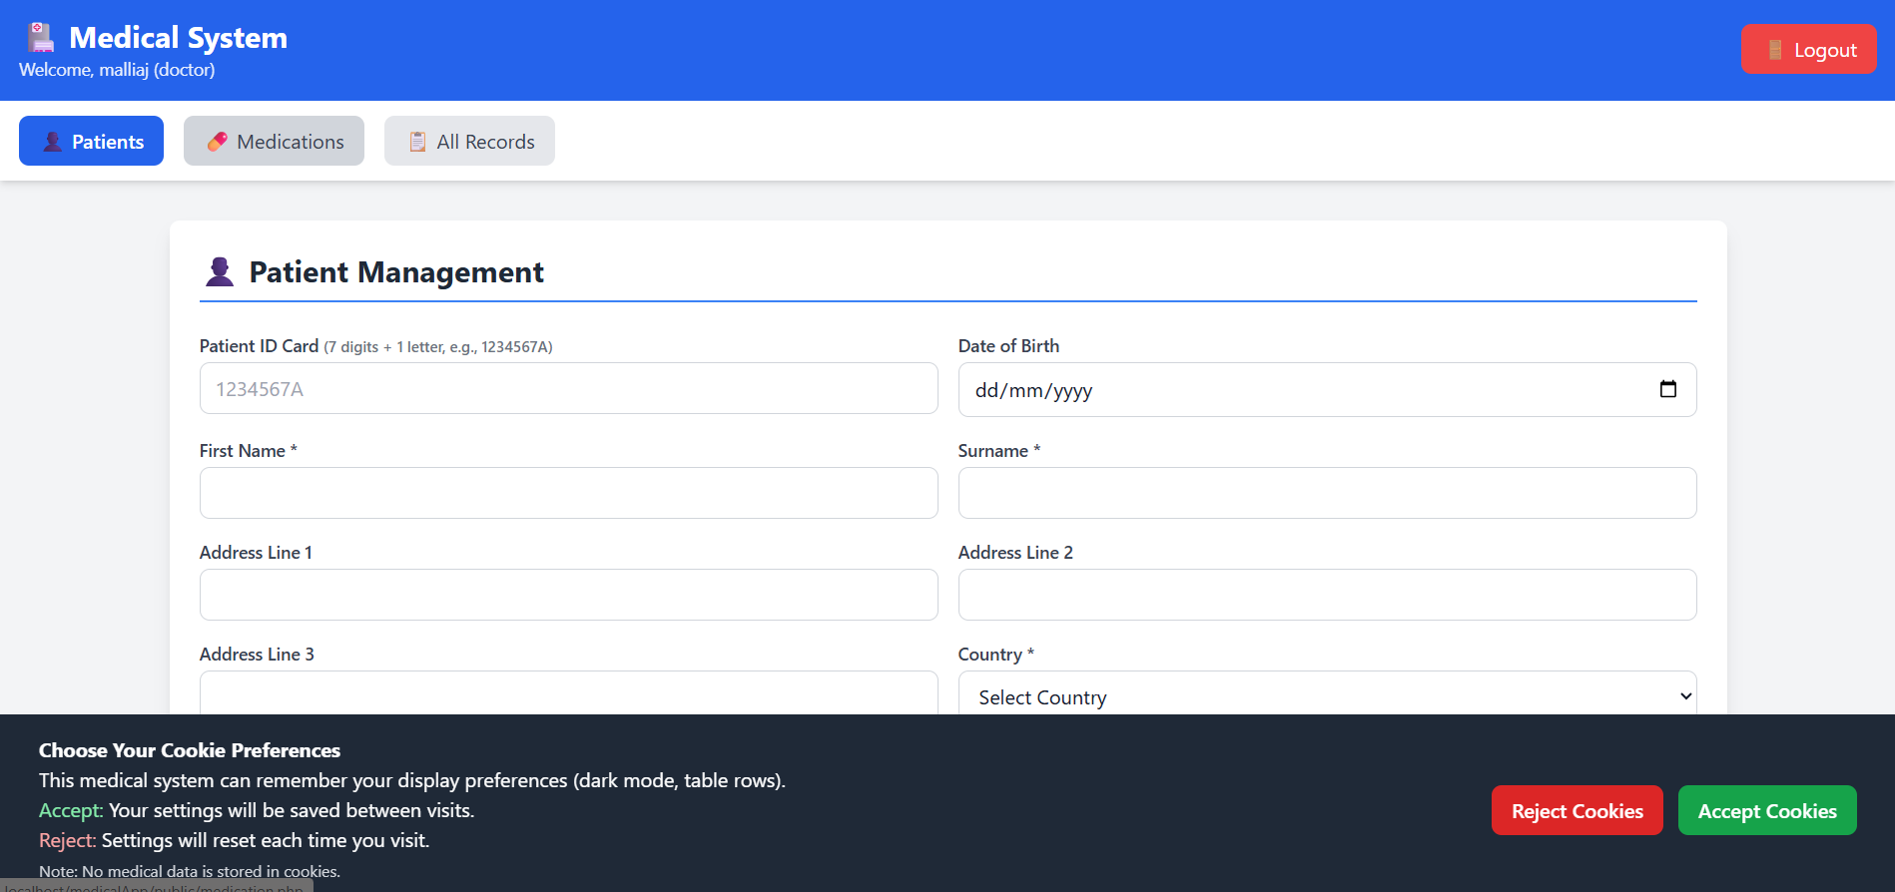
Figure 5 - Before Accepting Or Rejecting Cookies

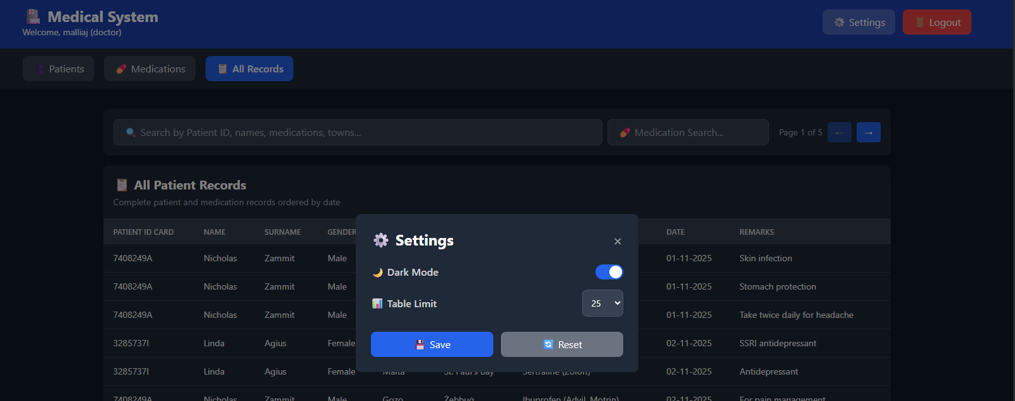
Figure 6 - Changing Cookies' Settings

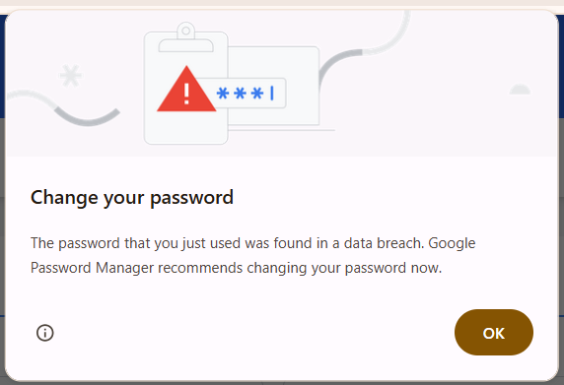
Figure 7 - Weak Password Notification

- Professional Accountability
Every patient record creation or prescription action is attributed to a specific healthcare provider, supporting liability protection and clinical governance through the backend for security purposes, as highlighted above. (Prictor, 2023).

Entity Relationship Diagram (ERD) Analysis

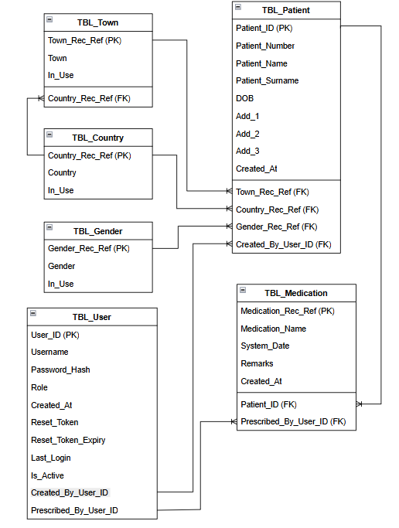
Figure 8 - Entity Relational Diagram

Database Architecture
The system’s ERD outlines a normalised relational database composed of six core entities designed to ensure data reliability, consistency and integrity.
- TBL_Country & TBL_Town
These tables establish a geographic hierarchy supporting Malta and Gozo. These two islands are within one archipelago, and some villages have the same name. Pre-populated entries reflect the local healthcare context while retaining the ability to scale internationally. (TAN, 2025). The relationship takes care that no used data is deleted, as data integrity will be lost; however, it allows for the inclusion of new towns if needed.
- TBL_Gender
Supports inclusive demographic classification by allowing Male, Female, and Other. More specific gender types can be included if needs arise.
- TBL_Patient
This table forms the system’s core, containing identifiers such as Patient_ID and Patient_Number, personal information, address structure, and essential audit fields such as Created_By_User_ID and timestamps. If a patient opts to be deleted from MS, all linked data to that patient, including medication data, will be deleted.
- TBL_Medication
Records contain medication name, prescribing date (System_Date), remarks, associated patient, and the Prescribed_By_User_ID, reinforcing full prescriber accountability.
- TBL_User
Stores authentication details, password hashing, user roles, and security tokens, enabling secure login and controlled system access (Omotunde, 2023).

Key Assumptions and Design Rationale

Professional Medical Hierarchy
The system assumes a traditional medical licensing model where only clinicians, not administrative staff, can prescribe medications. This reflects global medical standards and reduces the risk of unauthorised clinical actions (Mackey, 2011). Role-based restrictions are enforced at both UI and API layers to prevent circumvention.

Comprehensive Audit Trail
Given the sensitive nature of medical data, an immutable audit system is essential. Every action, patient creation, medication entry, and data modification is linked to a specific user (Vashishth, 2025). This enables:
- Legal and GDPR compliance (Edwards, 2019)
- Clinical quality oversight (Scruth, 2023)
- Insurance verification (this is not available in the current version; however, it can be added in the future) (Park, 2021)
- Protection in case of clinical disputes through historical information of assigned medication (Vaismoradi, 2021).

Geographic Specificity
Although designed for Malta and Gozo, the system’s architecture permits expansion and use in other countries. Preloading local towns ensures consistency in data entry while maintaining higher scalability and usage (Vítor, 2022).

Session-Based Security
The platform uses secure sessions, Cross-Site Request Forgery (CSRF) protection, password hashing, and role-based navigation (Sahu, 2024). These measures help ensure GDPR compliance and protect patient confidentiality (Barati, 2021).

Technical Architecture

Database Safety Features
- Constraint Checking: MS does not allow data duplication and ensures data integrity through constraint setup, both through front-end checks and back-end constraints (Caschetto, 2024).
- Backward Compatibility: Defaults ensure older records integrate smoothly with new schema changes (Link, 2021). This is taken care of by the database administration with additional front-end checks that ensure consistency of data.

Enhanced User Experience
- Real-time search across names, patient numbers, medication records, and locations is available through the MS application (Overmann, 2021). A responsive and fast interface using medical-themed emojis is used to enhance user experience.
- Role-specific badges and restricted navigation are provided to ensure the user experience is enhanced by providing additional information about the used role, as in Figure 9 - Role Information Display (Khalilova, n.d.).

Figure 9 - Role Information Display

Security and Compliance
- Medication information is provided through an API; however, as an extra enhancement to ensure service continuation, a JavaScript provides a basic popular medications normally used to ensure business continuation (Singh, 2022).
- The password is stored in a hashed manner within the database, ensuring basic security is provided (Zaland, 2021). In the future, additional encryption mechanisms can be used to enhance better secure protocols and channels.
- Secure password reset and session timeout are applied (Sahin, 2021).

Business Value and Clinical Impact

Operational Excellence
The MS greatly enhances workflow efficiency:
- Reduced administrative workload (Lavergne, 2023)
- Faster patient lookup and search functionality
- Prevention of unauthorised prescribing by controlling user accounts through assigned roles (Achar, 2021)
- Streamlined processes for clinicians and staff (Ayer, 2023)

Quality Improvement
This section will discuss further improvements that can be experienced through MS enhancements.

The system shall support data-driven quality assurance by providing prescribing pattern analysis at the patient’s level and in general (Lyu, 2025). The integration of AI tools can enhance this feature and allow for more accurate service and a better user experience (Virvou, 2023). Furthermore, doctors and nurses can keep abreast of the latest clinical trends provided.

Intelligence is another important functionality where evidence-based decision support is becoming imperative, ensuring the mitigation of practical errors from the doctors or nurses prescribing medication (Baurasien, 2023).

Risk Management
Audit trails and role restrictions protect both staff and patients by preventing unsafe clinical actions, enabling correction of errors, and providing legal defence when necessary (Sirrs, 2024). Additional database audit trails through triggers allow for a more robust system.

Further improvements
The platform is designed for long-term development and integration. Potential future features include:
- Use of eID integration for both patients and service providers (Kemppainen, 2023)
- Telemedicine modules (Krysta, 2021)
- Laboratory data integration (Guo, 2021)
- Drug interaction alerts (Achar, 2021)
- National health system connectivity
- Population health analytics
- Ability to store medical imaging and screening data (Alabduljabbar, 2024)
- Providing appointments and selection of consultants (Van Rossem, 2021)
- Integration of data from other systems through secure channels (Oladosu, 2022)

Conclusion
The Medical System exemplifies enterprise-grade healthcare software, aligning clinical workflows, professional accountability, and regulatory compliance with modern technical practices (Qalavand, 2025). Its focus on secure patient management, detailed audit trails, and role-based permissions ensures it is suitable for real-world medical environments while remaining scalable for future enhancements (Reddy, 2025).

References
Achar, S. S. N. a. N. W., 2021. The adoption and increased use of electronic prescribing of controlled substances.. Journal of Medical Regulation, 107(2), pp. 8 - 16.
Alabduljabbar, A. K. S. A. A. A. F. a. A. Y., 2024. Medical imaging datasets, preparation, and availability for artificial intelligence in medical imaging. Journal of Alzheimer's Disease Reports, 8(1), pp. 1471 - 1483.
Ayer, M., 2023. Relieving administrative burden on clinical staff with streamlined workflows and speech-recognition software. British Journal of Nursing, 32(16), pp. 1 - 9.
Barati, M. A. G. L. J. D. K. R. O. C. M. a. R. R., 2021. Privacy-aware cloud auditing for GDPR compliance verification in online healthcare.. IEEE Transactions on Industrial Informatics, 18(7), pp. 4808 - 4819.
Barbieri, C. N. L. S. S. M. F. a. M.-G. J., 2023. From electronic health records to clinical management systems: how the digital transformation can support healthcare services.. Clinical Kidney Journal, 16(11), pp. 1878 - 1884.
Baurasien, B. A. H. A. D. A. M. A. A. A. A. A. S. A. Z. A. K. a. A. H., 2023. Medical errors and patient safety: Strategies for reducing errors using artificial intelligence. International journal of health sciences, 7(1), pp. 3471 - 3487.
Bora, S. M. M. M. S. M. O. M. V. a. M. C., 2024. Streamlining Healthcare: An Efficient Health Records Management System. In 2024 16th International Conference on Electronics, Computers and Artificial Intelligence (ECAI). IEEE, pp. 1 - 5.
Caschetto, R., 2024. An integrated Web platform for remote control and monitoring of diverse embedded devices: A comprehensive approach to secure communication and efficient data management. Doctoral dissertation, Politecnico di Torino.
Edwards, S., 2019. Review of a medical illustration department’s data processing system to confirm general data protection regulation (GDPR) compliance.. Journal of visual communication in medicine, 42(3), pp. 140 - 143.
Guo, Y. Z. Y. L. T. P. M. W. F. X. H. a. B. J., 2021. The application of artificial intelligence and data integration in COVID-19 studies: a scoping review. Journal of the American Medical Informatics Association, 28(9), pp. 2050 - 2067.
Kemppainen, L. K. T. K. A. S. Y. K. L. E. V. T. &. K. H., 2023. Electronic identification (e-ID) as a socio-technical system moderating migrants' access to essential public services. The case of Finland. Government Information Quarterly, 40(4).
Khalilova, T., n.d. Evaluating and Enhancing User Experience in an existing UI Component Library.. 2025.
Kretschmer, M. P. J. a. W. K., 2021. Cookie banners and privacy policies: Measuring the impact of the GDPR on the web.. ACM Transactions on the Web (TWEB), 15(4), pp. 1 - 42.
Krysta, K. R. M. D. A. a. K. M., 2021. Telemedicine treatment and care for patients with intellectual disability.. International Journal of Environmental Research and Public Health, 18(4), p. 1746.
Lavergne, M. M. C. B. F. B. R. E. J. G. A. H. L. L. M. M. M. M. E. a. M.-M. R., 2023. Understanding and addressing changing administrative workload in primary care in Canada: protocol for a mixed-method study. BMJ open, 13(12).
Link, S. a. W. Z., 2021. Logical schema design that quantifies update inefficiency and join efficiency.. In Proceedings of the 2021 International Conference on Management of Data, pp. 1169 - 1181.
Lyu, G., 2025. Data-driven decision making in patient management: a systematic review.. BMC Medical Informatics and Decision Making, 25(1), p. 239.
Mackey, T. a. L. B., 2011. The global counterfeit drug trade: patient safety and public health risks.. Journal of pharmaceutical sciences, 100(11), pp. 4571 - 4579.
Meeker, W. & Hong, Y., 2014. Reliability meets big data: opportunities and challenges.. Quality engineering, 26(1), pp. 102 - 116.
Oladosu, S. I. A. I. C. A. P. A. O. a. A. A., 2022. Reimagining multi-cloud interoperability: A conceptual framework for seamless integration and security across cloud platforms. Open Access Res J Sci Technol, 4(1), p. 26.
Omotunde, H. a. A. M., 2023. A comprehensive review of security measures in database systems: Assessing authentication, access control, and beyond.. Mesopotamian Journal of CyberSecurity, pp. 115 -133.
Overmann, K. W. D. X. C. B. S. a. B. L., 2021. Real-time locating systems to improve healthcare delivery: A systematic review. Journal of the American Medical Informatics Association, 28(6), pp. 1308 - 1317 .
Park, S. C. J. a. B. J., 2021. Key principles of clinical validation, device approval, and insurance coverage decisions of artificial intelligence.. Korean journal of radiology, 22(3), p. 442.
Prasanna, B. K. P. a. V. M., 2024. The role of quality assurance in clinical trials: Safeguarding data integrity and compliance.. Cureus, 16(8).
Prictor, M., 2023. Where does responsibility lie? Analysing legal and regulatory responses to flawed clinical decision support systems when patients suffer harm.. Medical Law Review, 31(1), pp. 1 - 24.
Qalavand, M., 2025. The Exigency and Intricacies of Decentralized Clinical Trial Implementation within the Iranian Health Research Ecosystem. Available at SSRN 5232710..
Reddy, K. S. G. P. S. N. M. H. S. a. S. K., 2025. AI-Driven Healthcare Management Platform: Enhancing Accessibility, Efficiency, and Security in Digital Health Systems. Synthesis:. A Multidisciplinary Research Journal, 3(1), pp. 1 - 14.
Rizzardi, A. S. S. a. C.-P. A., 2024. IoT-driven blockchain to manage the healthcare supply chain and protect medical records.. Future Generation Computer Systems, Volume 161, pp. 415 - 431.
Sahin, S. a. L. F., 2021. Don't forget the stuffing! revisiting the security impact of typo-tolerant password authentication. Proceedings of the 2021 ACM SIGSAC Conference on Computer and Communications Security, pp. 252 - 270.
Sahu, S., 2024. Web Security for PHP Applications. In Building Secure PHP Applications: A Comprehensive Guide to Protecting Your Web Applications from Threats, pp. 125 - 175.
Saproo, S. G. P. D. J. &. G. K., 2025. Securing Patient Rights and Safety in a Digitally Transformed Healthcare Environment. Exploration of Transformative Technologies in Healthcare, 6(IGI Global Scientific Publishing), pp. 361 - 390.
Scruth, E. B. R. a. L. L., 2023. Quality Improvement and Clinical Audits: What Is the Ethical Oversight?.. Clinical Nurse Specialist, 37(5), pp. 211 - 213.
Semantha, F. A. S. S. B. Y. K. a. B. A., 2021. A conceptual framework to ensure privacy in patient record management system. IEEE Access, Volume 9, pp. 165667 - 165689.
Shahid, J. A. R. K. A. A. T. S. S. a. A. A., 2022. Data protection and privacy of the internet of healthcare things (IoHTs).. Applied Sciences, 12(4), p. 1927.
Singh, K. R. P. a. S. R., 2022. E Pharmacy..
Sirrs, C., 2024. The moment of patient safety: Iatrogenic injury, clinical error and cultures of healthcare in the NHS. Social History of Medicine, 37(1), pp. 93 - 115.
TAN, K., 2025. Transforming Ghana's National Health Insurance Scheme: A Comprehensive Audit and Policy Framework for Document Control, Records Management, and Administrative Excellence..
Vaismoradi, M. J. S. L. P. A. S. a. G. M., 2021. A systematic review of the legal considerations surrounding medicines management.. Medicina, 57(1), p. 65.
Van Rossem, A., 2021. Assessment and selection of management consultants: A comparative cognitive study between small-and large-scale companies. Journal of purchasing and supply management, 27(1), p. 100673.
Vashishth, T. S. V. S. K. K. B. C. S. a. P. R., 2025. Securing the Cloud: Strategies for Protecting Sensitive Patient Data in Cloud-Based Healthcare Recommender Systems.. Healthcare Recommender Systems: Techniques and Recent Developments, pp. 185 - 220.
Virvou, M., 2023. Artificial Intelligence and User Experience in reciprocity: Contributions and state of the art.. Intelligent Decision Technologies, 17(1), pp. 73 - 125.
Vítor, G. R. P. S. S. a. P. F., 2022. A scalable approach for smart city data platform: Support of real-time processing and data sharing.. Computer Networks, Volume 213, p. 109027.
Zaland, Z. B. S. M. S. a. A. M., 2021. Three-tier password security algorithm for online databases.. In 2021 2nd International Informatics and Software Engineering Conference (IISEC) IEEE, pp. 1 - 6.

